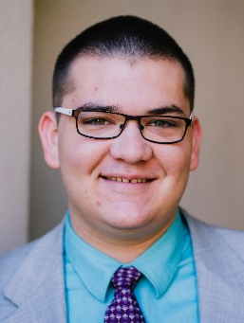
Andrew C. Ward
(801)-860-5336 218 W 900 N American Fork, UT
ward.andrew235@gmail.com

EDUCATION
American Fork High School, American Fork, UT 3.87/4.0 GPA
Currently Attending

Mountainland Applied Technology College, Lehi, UT
Currently Attending

EXPERIENCE
· East Shore Online High School, American Fork, UT March 2017 – Present
Use jQuery to make interactive online assignments

· Horrocks Engineers Sept 2016 – March 2017
Worked as a Jr. Field Technician in the fiber optics department doing CAD and data entry

- Boondocks Team Member May 2016 – Sept 2016
Worked at Boondocks Fun Center in Draper as an indoor team member

ACTIVITIES AND LEADERSHIP
Youth Leader President and Counselor 2012 – Present
. Meet every Sunday for church.
· Meet every Wednesday for mutual activities.
American Fork Marching Band 2012 - 2015
· Played percussion instruments.
· Practiced three times a week and went to competitions with occasional week-long and weekend camps.
· First in the state and region 2013, 2014, 2015.
· Took 17th at Grand Nationals in Indianapolis.
· Participated in 2014 annual Macy’s Day Parade.
Christa McAuliffe Space Education Center 2012 – 2014
· Volunteered 80+ hours.
· Help run Star Trek-like simulations for people by being behind the scenes and and acting as a space alien or human.
Boy Scout 2012-Present
· Life scout in Boy Scouting program.
· Meet every Wednesday for activities and occasional service projects and campouts on other days.
· Participated on staff of National Youth Leadership Training Summer Camp 2015

SKILLS
Piano and Percussion 2006 - Present
· Can practice, read, and play music well.
· 6 years of piano and percussion lessons.
· Percussion ensembles have taken 1st or 2nd most years.
Computers
· I took AP computer science and Mobile App Devolopment my Junior year.
· I took computer programming my Sophmore year, and did some android mobile programming.
· I know Java, HTML, CSS,Javascript. I also have set up a windows 10 website server, a linux apache2 website server, and I’m comfortable with many linux commands.
- Summer of 2016 I took a coding camp called Code to Success and graduated from it proficient in HTML, CSS, and Javscript; and also learned Git, Node.js, and Express.js.
- Learned AngularJS (1.6 & 2), MongoDB, TypeScript, Ionic Framework, and more at MATC.
· Efficient in Microsoft word, excel, powerpoint, much more computer software.
French Speaker 2015 - 2016
· I took 4 years of French

INTERESTS
Percussion – Marching Band – Math – Science – Engineering – Computers – French language & culture

REFERENCES
· Lynne Yocom (Programming Teacher) – lyocom@utah.gov
· Rachel McFarland (French Teacher) - (801) 756-0180
· Jimmer Standring (Religious Advisor) - (385) 224-9683

